**Experiment No 2**

**Aim :** 8086 Assembly language programming for Addition and subtraction of two 16 bit numbers

**Requirement :** Emu8086 (Assembler and Microprocessor emulator)

**Theory :**

1. **Data transfer instructions**

Data transfer instructions are used to transfer data from source operand to destination operand

**MOV instruction**

MOV instruction moves data from one location to another. It also has the widest variety of parameters; so it the assembler programmer can use MOV effectively, the rest of the commands are easier to understand.

**Format:** MOV destination,source

Logically, destination = destination + source

**Eg**. MOV AX,6

1. **Arithmetic instructions** 
   1. **ADD instruction**

ADD adds the contents of the source to the destination. The source and destination may be either bytes or words but both operands must be the same type or the assembler will generate an error.

If the sum of the two numbers cannot fit in the destination, an extra bit is required and this is signalled by the ADD operation setting the carry flags (CF) to 1. If the sum fits without spillage, CF=0. Other registers can be affected by addition operations as well; ZF=0 if the sum is zero, SF=1 if the sum is negative, etc. The logic of the basic addition command is:

**Format: ADD** destination,source

Logically, destination = destination + source

**Eg.** ADD AX,BX

* 1. **SUB instruction**

SUB subtracts the source value from the destination. Operation is almost identical to addition, except that the CF flag is used as a borrow in the case of the SBB (subtract with borrow) instruction.

**Format: SUB** destination,source

Logically, it is destination = destination - source

destination = destination - source - carry (if required)

**Eg.** SUB AX,BX

**Flowchart :**

**Flowchart for 16 bit numbers addition**

START

Load data into 16 bit registers

Stop

Store result into dx register

Add data

**Flowchart for 16 bit numbers subtraction**

START

Load data into 16 bit registers

Stop

Store result into dx register

Subtract data

**16 Bit Addition :**

**Program:**

data segment

a dw 4121h

b dw 1742h

c dw ?

data ends

code segment

assume cs:code,ds:data

start:

mov ax,data

mov ds,ax

mov ax,a

mov bx,b

add ax,bx

mov cx,ax

mov c,cx

int 3

code ends

**end start**

|  |  |  |  |
| --- | --- | --- | --- |
| **MEMORY LOCATION** | **OP-CODE** | **LABEL** | **MNEMOIC** |
| **O7110h**  **07113H**  **07115H**  **07118H**  **0711CH**  **0711EH**  **07120H**  **07124H** | **B8**  8E  A1  8B  03  8B  89  CC |  | **mov ax,data**  **mov ds,ax**    **mov ax,a**  **mov bx,b**    **add ax,bx**    **mov cx,ax**  **mov c,cx**  **int 3** |

**16 Bit Subtraction :**

**Program:**

data segment

a dw 21A6h

b dw 1022h

c dw ?

data ends

code segment

assume cs:code,ds:data

start:

mov ax,data

mov ds,ax

mov ax,a

mov bx,b

sub ax,bx

mov cx,ax

mov c,cx

int 3

code ends

end start

|  |  |  |  |
| --- | --- | --- | --- |
| **MEMORY LOCATION** | **OP-CODE** | **LABEL** | **MNEMOIC** |
| **7110H**  **07113H**  **07115H**  **07118H**  **0711CH**  **0711EH**  **07120H**  **07124H** | **B8**  A1  8B  2B  8B  89  CC |  | **mov ax,data**  **mov ds,ax**    **mov ax,a**  **mov bx,b**    **sub ax,bx**    **mov cx,ax**  **mov c,cx**    **int 3** |

**Result :**

**Output OF 16 BIT ADDITION :**

|  |  |  |  |
| --- | --- | --- | --- |
| **INPUT** | | **OUTPUT** | |
| **REGISTER** | **DATA** | **REGISTER** | **DATA** |
| **AX** | **4121** | **AX** | **5863** |
| **BX** | **1742** |  |  |

**Output OF 16 BIT SUNTRACTION :**

|  |  |  |  |
| --- | --- | --- | --- |
| **INPUT** | | **OUTPUT** | |
| **REGISTER** | **DATA** | **REGISTER** | **DATA** |
| **AX** | **21A6** | **AX** | **1184** |
| **BX** | **1022** |  |  |

**SCREENSHOT :**

**16 Bit Addition :**

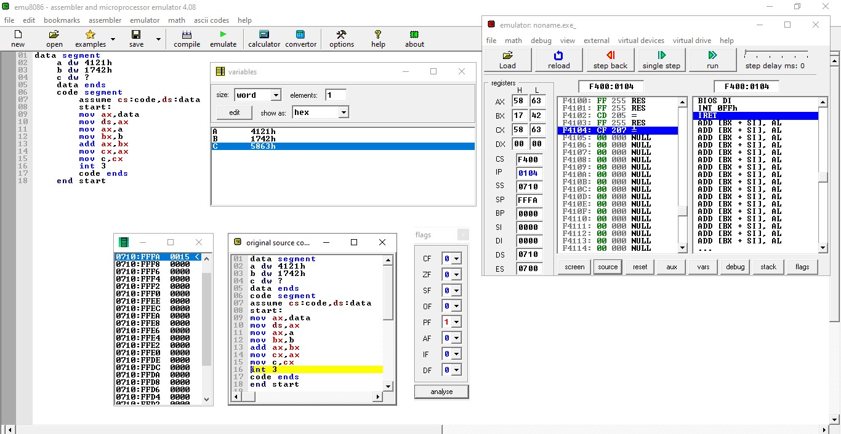

**16 bit subtraction :**

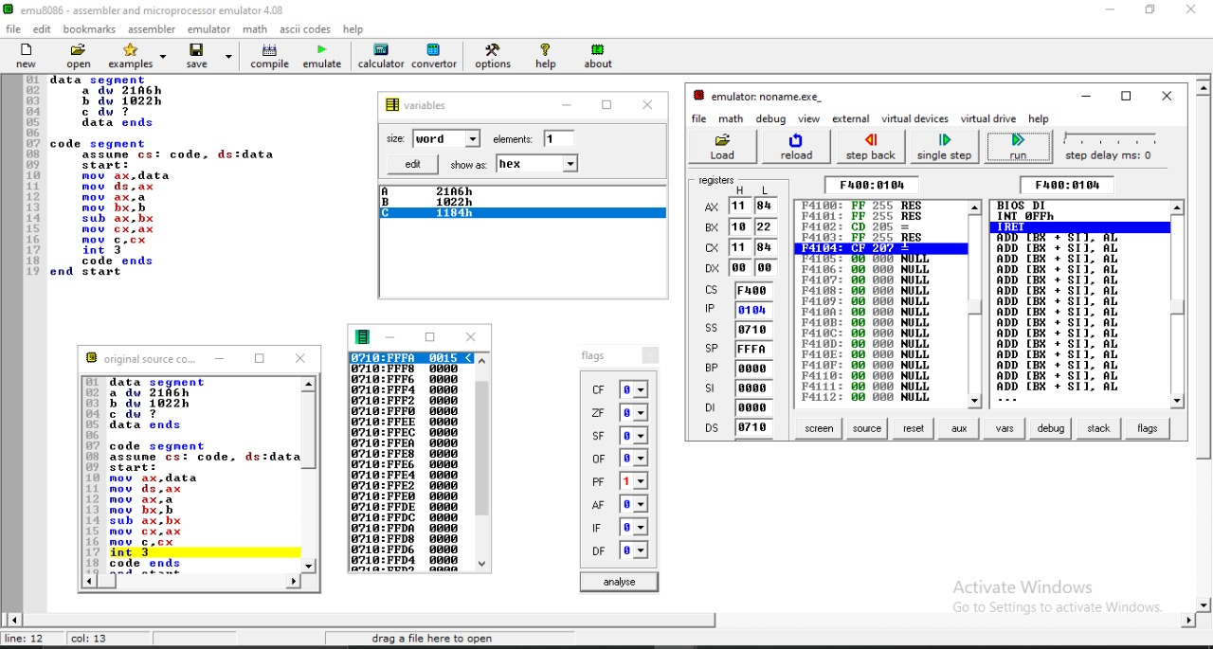

**CONCLUSION :**

Thus ,we performed 16 bit addition and 16 bit subtraction using AX ,BX and CX register. We used MOV , ADD and SUB instructions during the procedure.

**Experiment No 3**

**Aim :** 8086 Assembly language programming for Addition of series of 16 bit numbers

**Requirement :** Emu8086 (Assembler and Microprocessor emulator)

**Theory :**

1. **Data transfer instructions**

Data transfer instructions are used to transfer data from source operand to destination operand

* 1. **MOV instruction**

MOV instruction moves data from one location to another. It also has the widest variety of parameters; so it the assembler programmer can use MOV effectively, the rest of the commands are easier to understand.

**Format:** MOV destination,source

Logically, destination = destination + source

**Eg**. MOV AX,6

* 1. **LEA instruction**

LEA instruction determines the offset of the variable or memory location named as the source and puts this offset in the indicated 16-bit register. LEA does not affect any flag.

**Syntax :** LEA Register, Source

**Example :** LEA AX,14

1. **Arithmetic instructions** 
   1. **ADD instruction**

ADD adds the contents of the source to the destination. The source and destination may be either bytes or words but both operands must be the same type or the assembler will generate an error.

If the sum of the two numbers cannot fit in the destination, an extra bit is required and this is signalled by the ADD operation setting the carry flags (CF) to 1. If the sum fits without spillage, CF=0. Other registers can be affected by addition operations as well; ZF=0 if the sum is zero, SF=1 if the sum is negative, etc. The logic of the basic addition command is:

**Format: ADD** destination,source

Logically, destination = destination + source

**Eg.** ADD AX,BX

* 1. **DEC instruction**

DEC instruction subtracts 1 from the destination word or byte. The destination can be a register or a memory location. AF, OF, SF, PF, and ZF are updated, but CF is not affected. This means that if an 8-bit destination containing 00H or a 16-bit destination containing 0000H is decremented, the result will be FFH or FFFFH with no carry (borrow).

**Syntax :** DEC Destination

**Example :** DEC AX

1. **Logical instructions**

**CMP instruction**

This instruction comes under **Logical Instruction.** This instruction compares a byte / word in the specified source with a byte / word in the specified

destination. The source can be an immediate number, a register, or a memory location. The destination

can be a register or a memory location. However, the source and the destination cannot both be memory

locations. The comparison is actually done by subtracting the source byte or word from the destination

byte or word. The source and the destination are not changed, but the flags are set to indicate the results of

the comparison. AF, OF, SF, ZF, PF, and CF are updated by the CMP instruction. For the instruction

CMP CX, BX, the values of CF, ZF, and SF will be as follows:

**Syntax : CMP Destination, Source**

**Example :** CMP AL, 01H

1. **Transfer Of Control Instruction**

**JNZ instruction**

This instruction comes under **Transfer Of Control Instruction.** This instruction is usually used after a Compare instruction. If the zero flag is 0, then this instruction will cause a jump to the label given in the instruction.

**Example :**

ADD AX, 0002H

DEC BX

JNZ NEXT

**Flowchart :**

Start

Load data into 16 bit registers

Create loop and set counter variable to no of 16 bit numbers

Add data one by one with each other

Decrement counter variable for each iteration

Check whether the counter variables value Is not zero or not. if it is non zero then enter in the loop and add data.

store result into the dx register and then mov it to any variable

Stop

**Program :**

data segment

a dw 4200h, 5300h, 1600h, 8000h, 1900h

b dw ?

data ends

code segment

assume cs:code,ds:data

start:

mov ax,data

mov ds,ax

mov cl,5

lea bx,a

mov ax,00

OP: add ax,word ptr[bx]

add bx,02

dec cl

cmp cl,00

jnz OP

mov b,ax

int 3

code ends

end start

|  |  |  |  |
| --- | --- | --- | --- |
| **MEMORY LOCATION** | **OP-CODE** | **LABEL** | **MNEMOIC** |
| **7110h**  **7113h**  **7115h**  **7117h**  **711Ah**  **711Dh**  **711Fh**  **7122h**  **7124h**  **7127h**  **7129h**  **712Ch** | **B8**  **8E**  **B1**  **BB**  **B8**  **03**  **83**  **FE**  **80**  **75**  **A3**  **CC** |  | **mov ax,data**  **mov ds,ax**  **mov cl,5**  **lea bx,a**  **mov ax,00**  **OP: add ax,word ptr[bx]**  **add bx,02**  **dec cl**  **cmp cl,00**  **jnz OP**  **mov b,ax**    **int 3** |

**Result :**

**Output OF 16 BIT ADDITION :**

|  |  |  |  |
| --- | --- | --- | --- |
| **INPUT** | | **OUTPUT** | |
| **REGISTER** | **DATA** | **REGISTER** | **DATA** |
| **AX** | 4200h, 5300h, 1600h, 8000h, 1900h | **AX** | **4400h** |

**SCREENSHOT :**

